Transactions between Open Geospatial Consortium (OGC) Web Services (OWS) involving the Web Processing Service (WPS) standard examplified by hydrologic modelling
R. Béra^{1,2,3}, H. Squividant^{1,2,3} , P. Aurousseau^{1,2,3,4}
1Agrocampus Ouest, F-35000 Rennes, France
2INRA, UMR1069 Sol Agrohydrosystème Spatialisation,Rennes, France
3Université européenne de Bretagne, France
4Conseil Scientifique de l'environnement de Bretagne, France

Abstract. The proposal in the present paper is to make accessible the hydrology analysis tools that were developed by our research team in the past years through an interoperable Spatial Data Infrastructure. To this aim we chose to develop addons for the geOrchestra OGC-compliant platform. Such addons trigger algorithms and retrieve their output in real time through OGC standard WPS. We then introduce a watershed WPS addon and its functioning modes. In so doing we exemplify the fact that the use of OGC standards make it straightforward (and transparent to the user operating a common web browser) to remotely trigger a process on a distant server, then applied to distant data present on a remote cartographic server, and drop the outcome on a third-part cartographic server while visualising it all on a browser.
Keywords: OGC standards, Web Processing Service, addon, Spatial Data Infrastructure, geOrchestra, MNTSurf, hydrological modelling, watershed.
1. Introduction
Improving the use of spatial data, and analysis and modelling, tools in environment remains to be achieved to better support environmental and landuse management and planning. This observation especially pertains to water management where there is an avenue for improving the availability of public water-related data, and addressing the complexity of the field by providing real- or near real-time answers through the use of sufficiently realistic modelling.
A sound anwer to this challenging situation builds on a spatial data infrastructure (SDI) which allows for a wide access of geographical data and takes advantage of the ease of adding various analysis and modelling tools in order to bring extra functionalities to the public, namely a watershed delineation tool detailed in this paper's case study. As such watershed calculation is highly dependant on the quality and accuracy of topographic data: scale, resolution of, and protocol for computing, digital terrain models (DTM) itself highly dependant of corrective procedures. As a result a slight variation may lead to dramatic discrepancies in terms of watershed delineation and subsequent on-field resource management.
Our proposal is therefore to integrate a number of functionalities to a SDI based on the geOrchestra(a) (2009) software architecture, with an aim to assisting water management. In this paper we are focusing on watershed delineation from catchments.
The Geospatial Web now offers solutions and sofware to exchange data, and to some extent tools, including hydrological modelling ones (Feng et al., 2011 ; Castronova et al., 2012). However these components remain insufficiently interoperable or make a limited use of the potentialities offered by geospatial standards. Therefore, fostering interoperability appears as a priority if these tools are to serve the needs of a growing number of users including:
– research scientists, for the modelling of hydrological processes and polution transfer (pesticides, nitrates, dissolved organic fluids) is a prerequisite for a better understanding of water cycles;
– water managers and administerers: public water managing institutions, local governments, and other professionals with an interest in water quality and availability;
– the wider society, as in last resort water has to be administered for the benefit of all, and a straightforward manner of achieving this goal is to put every relevant element under the scrutiny of the common citizen, fostering people empowerment. This also addresses the requirements at national and European levels expressed in the Aarhus (1998) convention on environment. On a global scale the UN now consider water safety (access and quality of water ressources) as a priority for the comming years (UN, 2010).
In our view the convergence of technical, legal, as well as ethical, contexts is a plea towards the development and sharing of data and tools alike in the geospatial domain. This is suported by :
– the will at the EU level to ensure the availability and accessibility of public data (EU directive INSPIRE, 2007) by publishing data and providing the corresponding metadata, i.e. every piece of information that is relevant to the data, and possibly information to retrieve or access the data itself.
– the development of Open Data and the setup of a local, national, and global (DC, 2013) public service of data, amongst which geospatial.
– the good will of the key actors of geospatial information and software (including academics, private companies and developers, public administrations) to foster interoperability in systems and streams. From this respect the OGC is the structure of choice (OGC, 1994).
A starting point was the need to disseminate an expertise and knowledge built up in UMR SAS(b) (the authors' research team) in the field of hydrological modelling which materialised into tools which are broadly used at the national and local scales by watershed and catchment managers. Still, these tools remain insufficiently reachable and/or lack transparency/ease of use. In the present paper we put ourselves in the perspective of expanding the capabilities of our geOrchestra-based SDI GéoSAS with functions aimed at assinsting water ressource management. Our case study focuses on topographic delineation of watersheds.
We strongly support the idea that in order to ensure a maximal use/resuse/dissemination of systems, data, models and tools, a number of conditions must be fulfilled : (1) openness (FOSS SDI, open and public data, provide FOSS analysis tools and models) , (2) interoperability (compliance to OGC standards, inclusive and participatory developing process), (3) modularity (conceive the ovreall architecture as a bespoke structure made of substitutable software building blocks), (4) evolution-ability (easy integration of innovations and upgrades, e.g. processing services to publish tools, methods and models).
The paper is structured as follows : section 2 schemes through the technological options retained for our project, whereas section 3 introduces and details our approach, focusing on the Watershed WPS (WS-WPS) and associated addon, and demonstrate them in interaction with the other OWS used. Finally we draw a conclusion and perspectives in section 3.
2. Technology
The overall approach builds upon the OCG-compliant data architecture geOrchestra and implements extra specific code (based on MNTSurf).
geOrchestra. GeOrchestra (2009) is a Free Open-Source Software (FOSS) Spatial Data Architecture (SDA) which can be viewed as a consistent bundle of geospatial software amongst which:
– Geonetwork (catalog) ;
– Geoserver (cartographic/mapping server)
– mapfishapp (a viewer implemented with OpenLayers, GeoExt, ExtJS).
This SDA is implemented/instanciated as Spatial Data Infrastructure (SDI) GéoSAS (2009).
Web Processing Service. The WPS standard (OGC WPS, 2007) defines i/o and interactions between client- and server-side pertaining to processes (including models) on geospatal data. Input data can be local to the server or distant (on the client side), make use of image formats (e.g. GeoTIFF) as well as data exchange formats (Zipped SHAPE, GML, etc.). A process may have any degree of complexity. The WPS standard is designed to make processing services interoperable, hence enabling the effective interaction of such services as well as their reusability (and of course, reusability of associated code).
A WPS service must be able to execute thee types of operations (on the server side) as a result of a client's request.
– GetCapabilities requests are for the client to retrieve the service metadata (capabilities). Service metadata describe the aptitudes of the WPS server querried: name and description of each WPS hosted on the server, version of the standard used for client-server interaction.
– DescribeProcess requests return detailed information on how the services function: expected input type, possible outputs, available formats.
– Execute actually triggers the process, using the parameters selected through the client, and sends back the process' result.
MNTSurf. The services detailed further rely on MNTSurf (Squividant, 1994) software development udertaken at UMR SAS and dedicated to Digital Terrain Models (DTMs) in connection with hydrological modelling. This piece of software offers an novel method for DTM correction using a vector hydrology layer on the one hand, and a mechansism to remove flow anomalies based on a graph structure (drain tree) on the other hand (Aurousseau and Squividant, 1997). MNTSurf implements a representation of surface waterflows by means of a unidirectional as well as multidirectional drain model (Aurousseau and Squividant 1996).
MNTSurf is the core element for a number of research output: potential wet zones (Mérot, 2002), modelling of, nitrogen transfer and and transformation (Beaujouan et al., 2001, 2002) and, pesticide transfer (Tortrat et al., 2004),decision support system on water quality, environmental assesment of nitrogen overloaded catchments, monitoring of nitrogen flows in Brittany for local goverment (CSEB, 2008).
Amongst other functions MNTSurf was designed to
– calculate catchment extents and delineate watersheds upsteam any selected location. This location is therefore the outlet of the abovementtioned catchment, i.e. All surface flow within the watershed eventually flows through the location,
– compute hydrography networks as tree graphs,
– locate hydrological stations in the vicinity of any part of the hydrographic network.
3. MNTSurf inside geOrchestra with WPS
The novelty of the proposed tool relies on the implementation of services complying to the OGC WPS standard to the geOrchestra suite. A WPS is to be proposed to each function of MNTSurf. The operation of the WS WPS presented further in this paper may be generalised to all of MNTSurf's functions.
The result is a simplified access to automated watershed delineation (by clicking in a browser UI). The actual WPS (ensuring interoperable i/o) is triggered by an addon integrated to the SDI.
Figure 1 is an overview of, the stream kinds being used, and the software options actually used.

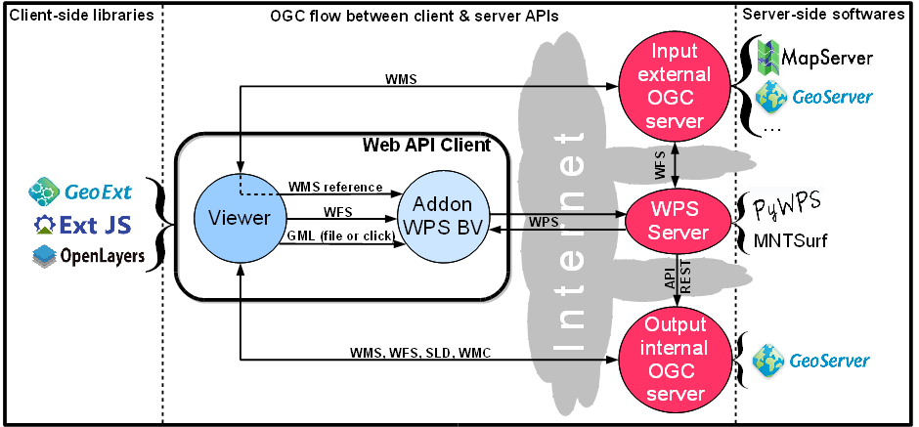
Figure 1. Schéma fonctionnel synthétique de l'architecture intégrant l'addon et le WPS BV.
Figure 1. Synthetic overview of the geOrchestra architecture enhanced with WPS.
Parameters. The WS WPS can be tuned trough the Hydrology / Watershed / Parameters menu which can be assessed by the toolbar of geOrchestra's viewer. One can thus select: the DTM/DEM to be used as input, the minimal areal extent of the watersheds to be calculated, the smoothing mode for the resulting watersheds' outline, and toggle automatic zoom on the result.
Execution. The WS WPS is triggered using the menu Hydrology / Watershed. It can manage alternatively four types of inputsm namely:
a) a mouse click on a location of the map, hence sending point coordinates (x,y);
b) a list of point coordinates in a GML file imported to the viewer by the user;
c) a reference to a whole point WMS layer (then the actual data flow directly between the OWS cartographic server and the WPS server.
d) an object (outlets, therefore of the point type) sélection from a WMS layer cast by a third party OWS server. A variant (e) consists of passing the reference to the selection instead of the selection itself in addition to the reference to the WMS layer.
Output and result. Once calculated the layer processed by the WS WPS is sent to a third party cartographic OWS server and added as a WMS layer to the list of visible layers in the viewer. This layer therefore benefits from all the OGC functionalities implemented on the viewer (the Web client) including: display (WMS(c)), download in SHAPE format (WFS^{(c)}), spatial and attribute requests (WMS, WFS), styling (SLD^{(c)}), context (WMC^{(c)}), etc.

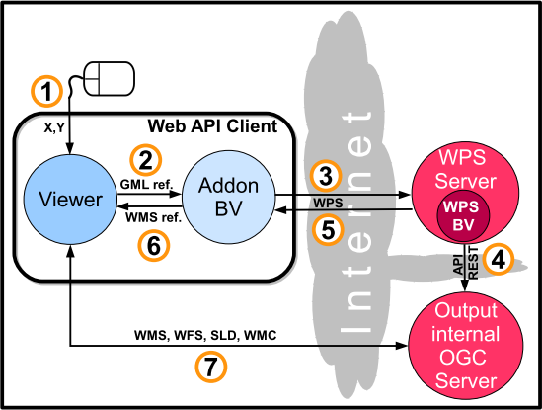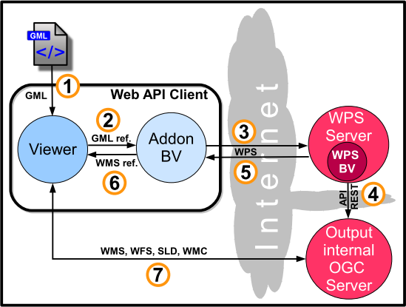
Fig. 2a. Fig. 2b.

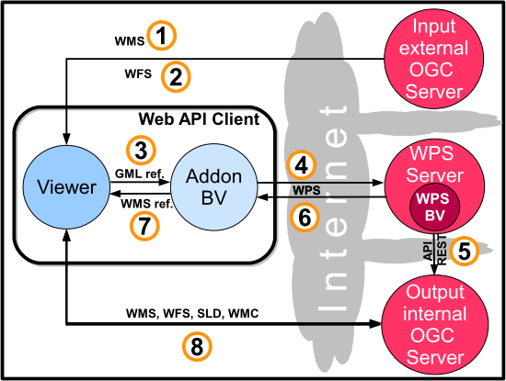
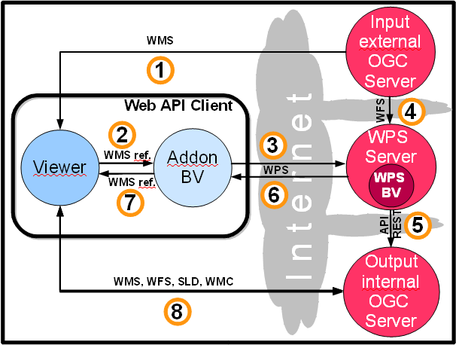
Fig. 2c. Fig. 2d.

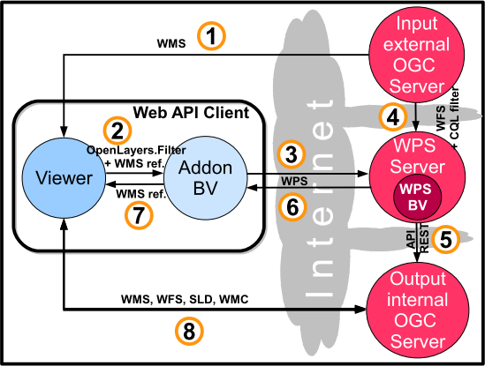
Flow succession from:
2a. a mouse click
2b. a GML spatial layer of points
2c. a reference to a whole OGC point layer
2d. a user-selected objects from an OGC point layer
2e. a reference to a OGC point layer plus the reference of a selection on this layer

Figure 2e.

Figure 2. Flows and transactions between the client and the servers depending on the WS addon's input type

Figure 2 shows the flow succession between the DSI modules from the execution of addon WS WPS depending on the chosen option (pertaining to the type of input): mouse click (fig. 2a), GML file ( fig. 2b), reference to an OWS layer (fig. 2c), selection within an OWS layer (fig 2d And 2e: in the first case the selection is sent through the Web whereas in the second example only the reference or description of the selection goes through). Table 1 complements figure 2 as a comparative list of data flow chronology for each option.

Table 1. Comparisson of the different flows streaming between the client and servers depending on addon WS's input. Numbers on first line (type of flow) refer to fig. 2a-e.

Figure 3 illustrates the use of addon WS and the WS WPS in geOrchestra's mapfishapp UI as it is accessed on the GéoSAS website (WS-WPS, 2013). A number of data layers are loaded as WPS and displayed in the viewer, as OpenStreetMap basemap, hydrology stations in Brittany, France. Some more basemaps are loaded though they are not displayed (unticked in the table of content): IGN map scan and composite multiresolution orthophoto. All these basemaps are available as OWS on GéoBretagne's cartographic server, whereas hyrology stations are retrieved from GéoSAS. A selection from the latter data layer is made, and the selected objects appear on the list below the maps (with associated attributes) as well as with an orange underline in the map itself. In our example the selection is that of all stations referenced as oulets of catchments more than 500 hectars in area (field bv at the right hand in the attribute table). Addon WS is then selected from menu tools/outils, with the process WS from selection/calcul BV depuis sélection option, which initiates the WPS request. The output, i.e. The waterseds which delineate catchments whose outlets are the abovementined selected stations, is then appended to the map canvas table of content as an OWS layer (in shades of blue on the map) and item named bv_date_time, respectively.

Figure 3. Addon WS and the outcome of WS WPS in geOrchestra's viewer.
5. Conclusion and Perspectives
In the present paper we demonstrate the dynamic (real-time) use of a hydrological analysis function in a web browser achieved by, extensively recursing to OGC standards, exclusively relying on FOSS, and taking advantage of the Open Data movement and european directive INSPIRE. This operational setup together with the standards from the OGC (for interoperability), and the software architecture retained (for its modularity) permit a straightforward transposition to other analysis tools and functions following the same principle, i.e. a concurrent use of, distant data available on a OGC-compliant cartographic server, and analysis or modelling processes available on a OGC-compliant process server, in order to perform a spatial computation (which by the way benefits from server's ressources) whose outcome may then be stored on a third party OGC-compliant cartographic server and subsequently visualised (real time) in the client web browser. This way wee demonstrate it is possible to seamlessly perform spatial analysis on delocalised data using delocalised processes.
Following the same principles we now work to make available an increasing number of MNTSurf functions as WPS, and facilitate access and use by associating geOrchestra addons to each of these (it is worth mentioning that every client implementing WPS, e.g. Quantum GIS through its WPS plugin. can use MNTSurf's functions irrespective of the use of geOrchestra and its addons). An objective is to offer the users WPS tools linking modelling and real-time on-field measurements (e.g. Macro Flux, Vinson, 2003).
Moreover, a number of addons to geOrchestra we developed are already available (e.g. Vidae, 2009, 2013), are being retuned as WPS. Vidae is dedicated to mining the data collected as on-going time-series by a number of environmental sensors disseminated on several experimental sites. The data collected include stream- and ground-water physical and chemical properties and composition, the sites being located in Brittany, France (two sites) and in the Medittrranean basin (one in France and one in Tunisia).
Moreover, we do not restrict ourselves to the field of hydrology when it comes to developping WPS, as we also produced soil database query tool as a WPS for projects Websol (Chafchafi et Bargeot, 2013) and soils of Brittany (SdB, 2013).
Also, other ongoing projects aim at increasing the number and variety of available WPS: putting GRASS's functions as WPS (52north.org), and a similar trend exists concerning ArcGIS. The perspective of having all the processes and models at disposal is likely to increase and transform practices in geomatics, and unify the different communities (which are largely based on software). The use of WPS transcends local (client-side) software as long as it includes a WPS client, and we showed we can even do without a desktop GIS at all, as we demonstrate a Web browser can do the job as long as at the servers end the architecture takes full advantage of OGC standards. Power
Nous nous inscrivons complètement dans cette démarche et en proposons de plus un usage simplifié ne nécessitant pas même l'installation d'un client SIG (par exemple QGIS et ses différents plugins OGC) : le seul prérequis est un navigateur web. La large diffusion des smartphones et tablettes, qui en sont munis est donc en passe de rendre la géomatique (données et outils) véritablement pervasive et ubiquitaire.

6. References
Aarhus, 1998 : Aarhus Convention. http://www.unece.org/fileadmin/DAM/env/pp/documents/cep43f.pdf
Aurousseau, P., Squividant, H., 1996 : Use of tree and graph structures for computation modelling of derived variables in digital elevation model software. http://viviane.roazhon.inra.fr/spanum/publica/dem/dem2.htm
Aurousseau, P., Squividant, H., 1997 : Correction of Digital Elevation Models using drainage pattern constraints. http://viviane.roazhon.inra.fr/spanum/publica/contrain/contrain.htm
Beaujouan, V.,Durand., P, Ruiz, L.,2001 : Modelling the effect of the spatial distribution of agricultural practices on nitrogen fluxes in rural catchments. Ecological Modelling. Elsevier : Volume 137 (1), pages 93-105
Beaujouan, V., Durand, P., Ruiz, L., Aurousseau, P., Cotteret, G., 2002 : A hydrological model dedicated to Topography-based simulation of nitrogen transfer and transformation. Rationale and application to the geomorphology-denitrification relationship. Hydrological Processes : vol.16 (2), p.493-507
BV-WPS, 2013 : http://geowww.agrocampus-ouest.fr/demo2013
Castronova, A.M,, Goodall, J.L., Elag, M.M., 2013 : Models as web services using the Open Geospatial Consortium (OGC) Web Processing Service (WPS) Standard. Environmental Modelling & Software, Volume 41, March 2013, Pages 72-83
CE, 1994 : Charte de l'environnement. http://www.legifrance.gouv.fr/affichTexte.do?cidTexte=JORFTEXT000000790249
Chafchafi, A., Bargeot, L., 2013 : Document de synthèse des travaux de l'axe 5 du RMT Sols et Territoires : Mettre à Disposition des Données Sols sur les Territoires. Document de travail, Chambre régionale d’Agriculture Rhône-Alpes et AgroSup Dijon / EDUTER / CNERTA / DISI.
CSEB, 2008 : Portail cartographique diffusant des informations sur la qualité des eaux (nitrate, pesticides) des bassins versants de Bretagne. Conseil Scientifique de l’Environnement de Bretagne (CSEB), Aquascop (Bureau d'étude). http://geowww.agrocampus-ouest.fr/web/?page_id=171
DC, 2013 : DataCatalogs.org : Data Catalogs Dot Org aims to be the most comprehensive list of open data catalogs in the world. It is curated by a group of open data experts from around the world. A project initiated during the Open Knowledge Foundation Conference 2011. http://datacatalogs.org/
DGF, 2011 : data.gouv.fr : Plateforme française d'ouverture des données publiques. Etalab.gouv.fr (Service du Premier Ministre Chargé de l'Ouverture des Données Publiques), http://www.data.gouv.fr/A-propos
Directive INSPIRE, 2007: http://inspire.jrc.ec.europa.eu/
Feng, M., Liu, S., Euliss, N.H., Young, C., Mushet, D.M., 2011 : Prototyping an online wetland ecosystem services model using open model sharing standards.
Environmental Modelling & Software, Volume 26, Issue 4, April 2011, Pages 458-468
geOrchestra, 2009 : http://www.georchestra.org/
GéoSAS, 2010 : http://geowww.agrocampus-ouest.fr/web/
Mérot, P., 2002 : Typologie fonctionnelle des zones humides de fond de vallée : les concepts de zones humides potentielles, effectives et efficaces. Zones Humides Infos, Volume 36, p.16
OGC, 1994 : Open Geospatial Consortium. http://www.opengeospatial.org/
OGC WPS standard, 2007 : http://www.opengeospatial.org/standards/wps
ONU, 2010 : Resolution Project A/64/L.63/Rev.1, United Nations Organization. http://doc.un.org/DocBox/docbox.nsf/GetFile?OpenAgent&DS=A/64/L.63/REV.1&Type=PDF
SdB, 2013 : Sols de Bretagne (Websol Bretagne). http://geowww.agrocampus-ouest.fr/portails/portail.php?portail=websol&mode=viewer&viewer=http://geowww.agrocampus-ouest.fr/sviewer&wmc=http://geowww.agrocampus-ouest.fr/wmc/bzh_FamilleDominante.wmc
Squividant, H., 1994 : MNTSurf : logiciel de traitement des modèles numériques de terrain. Document E.N.S.A.R.
Tortrat, F., Aurousseau, P., Squividant, H., Gascuel-Odoux, C., Cordier, M.O., 2004 : Modèle Numérique d'Altitude (MNA) et spatialisation des transferts de surface : utilisation de structures d'arbres reliant les exutoires de parcelles et leurs surfaces contributives. Bulletin SFPT, 172 p.128-136
Vidae, 2009 : VIsualisation de Données Agro-Environnementales. http://geowww.agrocampus-ouest.fr/web/?page_id=103
Vidae, 2013 : http://geowww.agrocampus-ouest.fr/portails/portail.php?portail=vidae
Vinson, J., 2003 : Calculs des flux annuels et des flux spécifiques annuels d’azote nitrique des principaux fleuves et rivières de Bretagne. Bretagne Environnement. http://www.bretagne-environnement.org/Media/Documentation/Bibliographies/Calculs-des-flux-annuels-et-des-flux-specifiques-annuels-d-azote-nitrique-des-principaux-fleuves-et-rivieres-de-Bretagne

(a)geOrchestra is a spatial data infrastructure initiated by the company CampToCamp following the specifications of Géobretagne (Brittany's regional SDI). These included requirements as the use of FOSS (incl. Geoserver, Geonetwork, Openlayers, etc.). The specific developpements in the project (especially viewer mapfishapp) also had to be FOSS, as this solution is percieved as the best guarantee for the ongoing development.
(b) Joint research unit between the French National Institute for Agronomical Research (INRA) and the Agrocampus Ouest agronomy college in Rennes, France. SAS stands for Soil Agrohydrosystems and Spatialisation (http://www.rennes.inra.fr/umrsas)
(c) Resp. Web Map Service, Web Feature Service, Styled Layer Descriptor, and Web Map Context. All are OGC standards (more details on http://www.opengeospatial.org/standards/{wms,wfs,sld,wmc})

